
Home Learning
Nursery rhyme of the week: Weekly
50 things to do before you’re 5: Weekly
Fridge words: Everyday

Reminders
Library: Please access our cloakroom library as often as you like.
Relaxed clothes: Children can come to Nursery DRESSED in PE/appropriate sports clothes and shoes on FRIDAYS. Please bring water bottles and spare clothes each day.

Oracy
Establishing talk guidelines

PHSE
Jigsaw: Being Me in My World
Daily mindful moment
Mindful meditation

Topic Launch
Rainbow pictures
Date: WB 01-09-26
Grand Finale
Autumn Walk
Date: 23-10-26
Aspire session
Stay and play
Date: 16-10-26

Personal, Social and Emotional Development
We will show more confidence in new social situations. We will select and use activities and resources, with help when needed. We will enjoy trying new activities. We will develop relationships with other children.

Physical Development
We will balance on a range of equipment and match our physical skills to tasks and activities within the setting. We will decide how to travel and balance on one leg. We will explore a range of fine motor resources and learn how to hold a pencil with a comfortable grip.

Communication and language
We will enjoy listening to longer stories and try and remember what has happened. We will begin to understand an instruction with two parts. We will use a wider range of vocabulary. We will know many rhymes and use some words we have learned in rhymes in our play.

Maths
We will follow the White Rose Maths scheme this year.
We will take part in finger rhymes with numbers.
We will make comparisons between objects.
We will talk about and explore 2D shapes using informal vocabulary.

Brown bear, Brown bear,
What can you see?

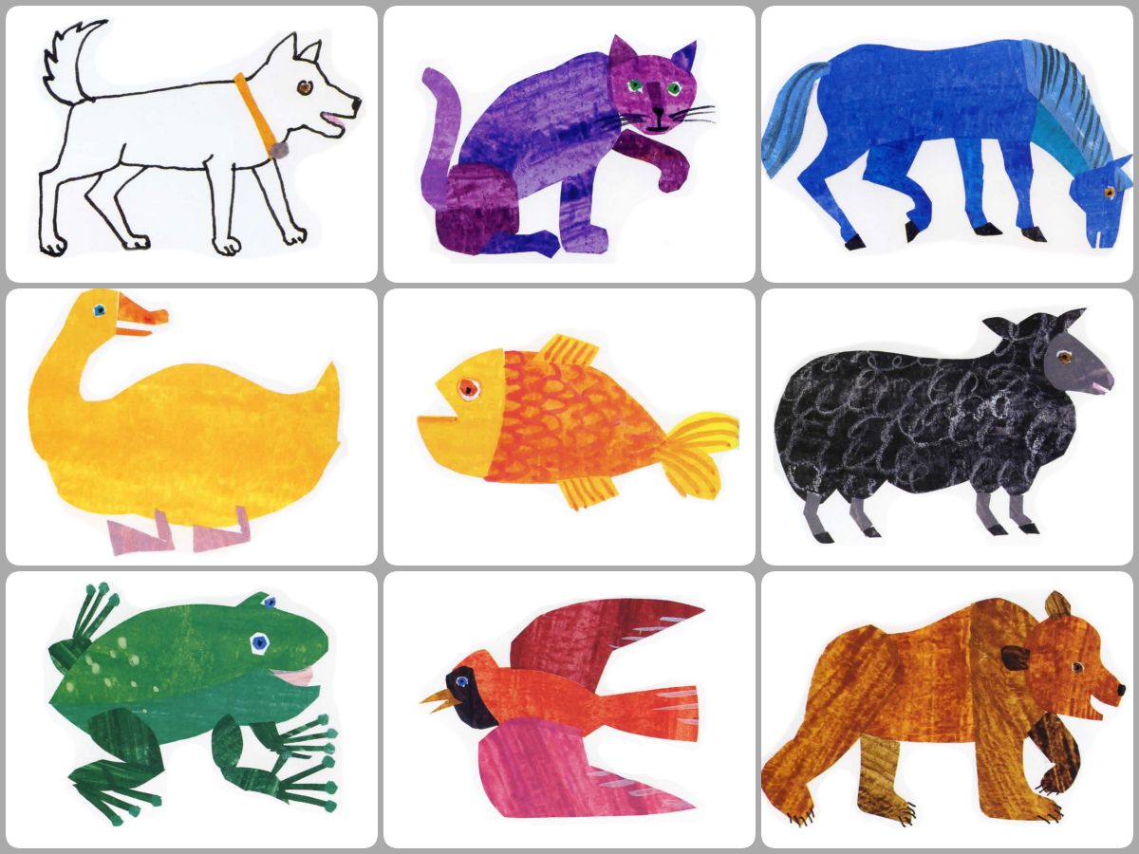

English
Week 1 – Brown bear Brown bear Week 5 – The little red hen
Week 2 – Brown bear Brown bear Week 6 – Oi Frog
Week 3 – Little Yellow Chick Week 7 – Autumn-Non fiction
Week 4 – Blue balloon Week 8- Autumn poems

Achieve
Outcomes
Maths Hub
Parent partnerships
Lifelong learners

Aspire
Acquisition of language – Fulfil our potential
Experiential learning – Lively enquiring minds
Curriculum
Pupil leadership – Make a positive contribution to society
Governors

Belong
Relationships and nurture
Well-being and mental health
British Values – Challenge to educate
RE and PSHE- Children are ready for a modern Britain
Transition

Hendal Primary School Curriculum Drivers and Half Term Overview Autumn 1 - 2026 Nursery

