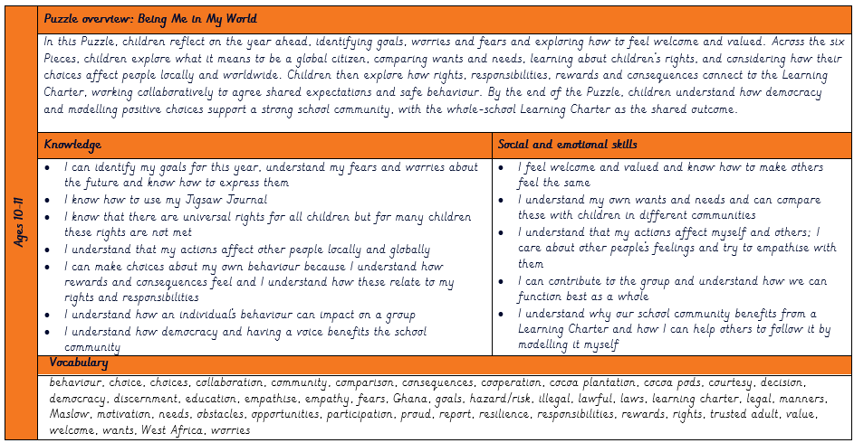
Hendal Primary School PSHE Curriculum Overview Autumn 1 Year 6
Dreams and Goals
Celebrating Differences
Being Me in My World
Healthy Me
Relationships
Changing Me
Being Me in My World

