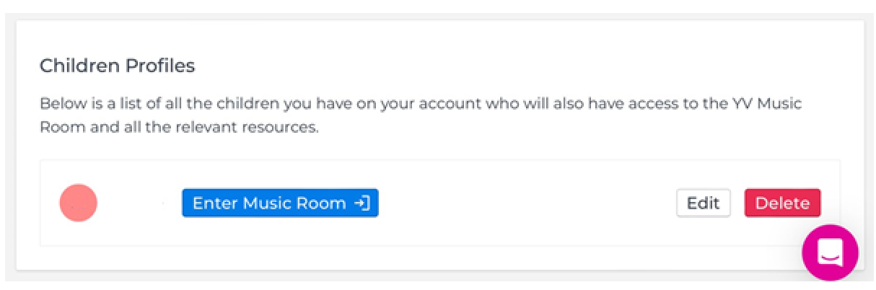
To pay for tickets/tshirts online in the Music room shop, please make sure you have Given Permission.
On the Children’s profiles page it will say give. If you are doing this on a mobile phone, please turn your phone to landscape as it cuts this off in portrait.
You are giving permission for your child to attend Young Voices. The terms are available for you to read when you click on give permission.
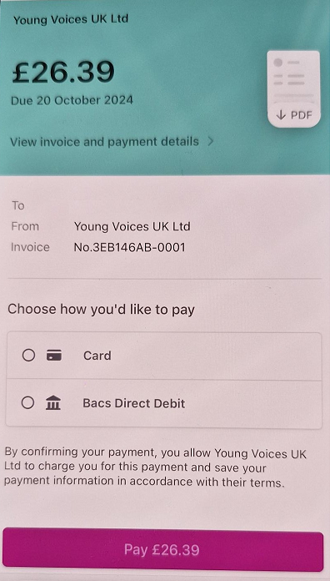
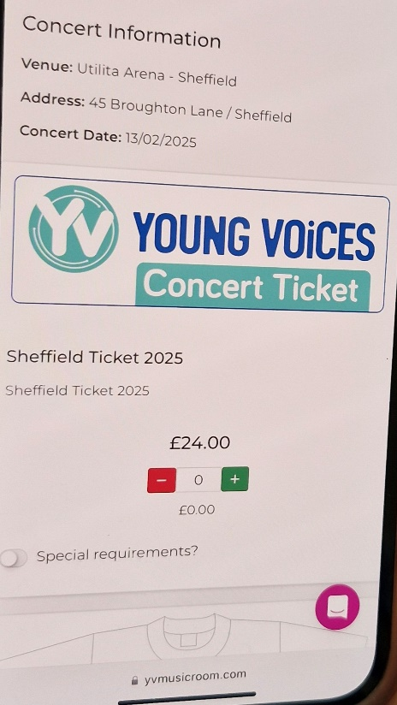
Once you have given permission, you will be able to go into the shop and order and pay.

