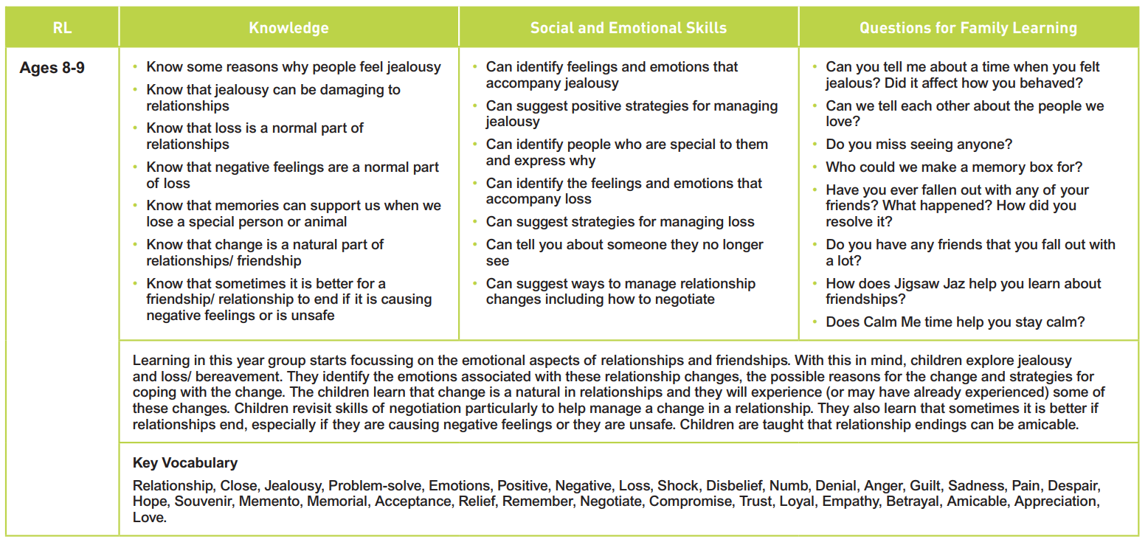

Healthy Me

Changing Me

Relationships

Healthy Me

Being Me in My World

Celebrating Differences

Dreams and Goals

Hendal Primary School PSHE Curriculum Overview Summer 1 Year 4