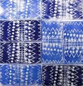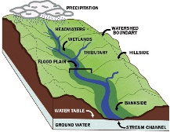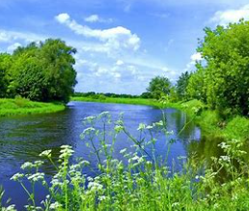

**English –** As writers, we will be looking at a poem by Valerie Bloom ‘*The River*.’ We will be using this text to inspire our own poems on rivers. We will also be reading ‘*Song of the River’* and will be writing our own persuasive letters.

**Spelling –** We will practice spelling rules for ‘SC’ words, ‘sion’ words and homophones.

**Art and Design-** As artists, children will be learning about pattern, line and space so that they can create a 3-layer-poly-print using their own sea-side design.

**MFL**: The children will learn how to say sentences on their opinions of toys and food.

.

**RE:** TheChildren will be learning about why some people think life is a journey. They will learn about different rites of passage.

**PE –** We will be working on our skills in tennis.

**PSHE:** The children will be learning about love and loss. Children will share and discuss ways of dealing with difficult times.

**Geography –** As geographers, we will be learning about the features of rivers and how they are formed. We will then discuss the importance of rivers in our local environments and how people use them.

**Reading:** Please bring your book bag and reading book every day.

If you have read your reading book at home and an adult has recorded in your book diary, then please pop them both in the basket to be changed.

**PE Kit:** Please bring your PE kit to school every Monday and take it home on a Friday.

**Music –** As musicians, the children will be learning how to sing with ‘Junior Jam’

**Computing-** As Computer Technicians, the children will be using the 2Logo system on Purple Mash to create our own digital patterns.

**Maths:** As mathematicians, the children will continue to develop their understanding of tenths and hundredths as decimals and fractions. They will begin to learn about the value of money and amounts.

**Science Enquiry:** *What are the differences between solids, liquids and gases?* **Science Investigation:** Observing the changes of state – we will be measuring the temperature which chocolate melts the fastest.

**What are rivers and how are they used?**



**Homework and spellings:** Handed out **Friday** to be returned **Thursday**.

Our spelling and times table test will be on a **Friday.**

**Library:** Children have the opportunity to visit our school library on a **Monday** and change their books. Please ensure children return their library books every Monday.

Hendal Primary School Curriculum Drivers and Half Term Overview Summer 1

**Educational Visit:** As part of our topic, Year 4 will be going on a 2-night residential to Scarborough. During this time, the children will take part in a range of activities such as visiting *The Sea Life Centre* and taking part in a *Birds of Prey* workshop.

**Date:** 10.04.24 – 12.04.24

**Topic Launch:** Thechildren will visit Scarborough.

**Grand Finale:**

**Belong:** Scarborough residential.

**Aspire:** To look after rivers and our environment.

**Achieve:** To suggest ways we can improve our local environment.

**Experiential Learning**

**Outcome**: Lively enquiring minds.

**Acquisition of Language**

**Outcome**: Independent lifelong learners.

**Outdoor Learning**

**Outcome**: Healthy body and mind

**Partnerships**

**Outcome:** Positive contribution to society

**Wellbeing & Nurture**

**Outcome**: Caring for others.