Early Years Foundation Stage Policy

Hendal Primary School

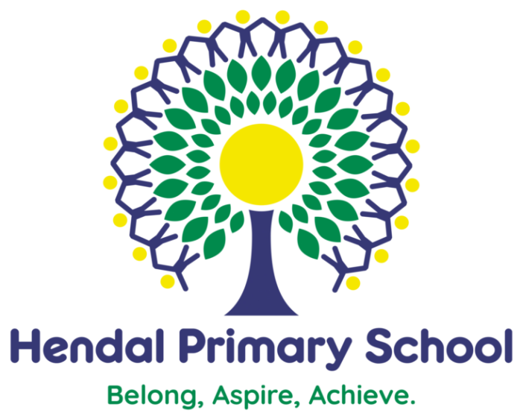

Early Years Foundation Stage Policy

Document Date: November 2021
Review Date: November 2023
Lead Personnel: Headteacher
Review frequency: Every 2 years

Introduction
‘Every child deserves the best possible start in life and support to fulfil their
potential. A child’s experience in the early years has a major impact on their
future life chances. A secure, safe and happy childhood is important in its own
right and it provides the foundation for children to make the most of their
abilities and talents as they grow up.’

(Early Years Foundation Stage Profile - Department for Children, Schools and Families 2012.)

The Early Years Foundation Stage applies to children from birth to the end of their Reception Year. At Hendal Primary School we have a Nursery and Reception provision within our Foundation Stage Unit.

We believe that early childhood is the foundation on which children build the rest of their lives and at Hendal Primary School we greatly value the importance that the EYFS plays in laying secure foundations for future learning and development.

Aims & Objectives
We aim to support all children to become independent and collaborative learners.
Across the Foundation Stage, we will provide a broad and balanced curriculum that will enable each child to develop personally, socially, emotionally, spiritually, physically, creatively and intellectually to their full potential.

At Hendal Primary School, we will:
- Provide a happy, safe, stimulating and challenging programme of learning
and development for the children to experience as they begin their journey
through school.
- Provide a broad, balanced, relevant and creative curriculum that will set in
place firm foundations for further learning and development in Key Stage 1, 2
and beyond and enable choice and decision making, fostering
independence and self-confidence.
- Use and value what each child can do, assessing their individual needs and
next steps and helping each child to progress. We will use a variety of
assessment methods including ongoing and more formalised observations
and the use of the 2Simple assessment tool.
- Develop positive relationships with parents and carers to build a strong
partnership in supporting their children.
- Provide a caring and inclusive learning environment which is sensitive to
the requirements of the individual child including those who have additional
needs.
The early-years education we offer our children is based on the following principles:
- It builds on what our children already know and can do;
- It ensures that no child is excluded or disadvantaged;
- It offers a structure for learning that has a range of starting points, content
that matches the needs of young children, and activities that provide
opportunities for learning both indoors and outdoors;
- It provides a rich and stimulating environment;
- It acknowledges the importance of a full working partnership with parents and carers and the benefits of sharing both successes and concerns withthem.

Learning and Developing
Our curriculum for the Foundation Stage reflects the learning aims and objectives set out in the Early Years Foundation Stage Curriculum.

There are seven areas of learning and development that must shape educational provision in all early years’ settings. All areas of learning and development are important and inter-connected and none can be delivered in isolation from the others. Our children’s learning experiences enable them to develop competency and skill across these areas of learning. They require a balance of adult led and child initiated activities in order for children to develop effectively and to give them the best chance of obtaining a good level of development at the end of their Reception Year. Three areas are particularly crucial for igniting children’s curiosity and enthusiasm for learning, and for building their capacity to learn, form relationships and thrive.

The three Prime areas are:
- Personal, Social and Emotional Development
- Communication and Language
- Physical Development

Staff will also support children in four specific areas, through which the three prime areas are strengthened and applied.

Specific Areas:
- Literacy
- Mathematics
- Understanding the world
- Expressive arts and design

If a child’s progress in any of the prime areas gives cause for concern, staff will discuss this
with the child’s parents/carers and agree how to support the child.

Characteristics of Effective Learning
We ensure that our environment and delivery of the curriculum incorporates the three characteristics of effective teaching and learning:

- Playing and exploring - children will have opportunities to investigate and experience things, and ‘have a go’.
- Active learning - children will have time and space to concentrate and keep on trying if they encounter difficulties, and enjoy their achievements.
- Creating and thinking critically - we encourage and support children to have and develop their own ideas, make links between ideas, and develop strategies for doing things.

Planning
The Early Years Foundation Stage Curriculum provides the basis for planning throughout the Foundation Stage. The planning objectives within the Foundation Stage are from the Development Matters Statements from the Early Years Foundation Stage document. The planning is based upon themes with discrete phonics, maths and other directed teaching. However, planning, which is based upon different topics that have been identified as vehicles of interest to enable us to deliver the children’s next steps in learning, also responds to their social and emotional needs as well as their achievement.

Assessment
During the first term, the teacher assesses the ability of each child using observations and activities. These assessments allow us to identify patterns of attainment within the cohort, in order to adjust the teaching programme for individual children and groups of children. This first /baseline assessment also takes into account any other records we receive from previous pre-school settings, parents and childminders. Most of our children have attended our nursery which helps to facilitate this process. The Foundation Stage Profile is the nationally employed assessment tool that enables teachers to record their observations at the end of the pupils’ Foundation Stage and to summarise their progress towards the Early Learning Goals. It covers each of the seven areas of learning contained in the curriculum guidance for the Early Years Foundation Stage.

We record each child’s level of development against the 17 areas of learning as Emerging, Expected or Exceeding. Observations and assessment of each individual pupil is on-going with the information gained being used to ensure that future planning reflects identified needs. The Foundation Stage Staff have weekly planning meetings to discuss each child and the ways we will adapt the provision to address their learning and any needs identified.
Assessment in the Foundation Stage takes the form of formal and informal observations, teacher, nursery nurse and teacher assistant knowledge of the pupils and photographic evidence. Assessment is completed regularly and involves both the teacher and other adults, as appropriate. The collection of assessment data in the Foundation Stage Profile is a statutory requirement.

Assessment data is recorded in each child’s Learning Journey and collating examples of each child’s work. The Learning Journeys contain a wide range of evidence that we share with parents at each parental consultation meeting.

At the end of the final term of a pupil’s Reception Year we send a summary of these assessments to the LA for analysis. The child’s next teacher uses this information to make plans for the year ahead. We share this information too at parental consultation meetings and in the end of year report.

Parents receive an annual written report that offers comments on each child’s progress in each area of learning. It highlights the child’s strengths and developmental needs, and gives details of the child’s general progress. We complete these in the Summer Term and send them to parents before the end of the school year.

The Learning Environment
Our Foundation Stage is organised to allow children to explore and learn securely and safely.
Children have access to both the inside and the outside environment at various points in the day which is known to have a positive effect on the children’s development. The Early Years Foundation Stage pupils have their own outdoor area with sand and water, climbing equipment, writing opportunities, mud kitchen, construction and role play. Spending time outdoors offers opportunities for exploring and learning things differently to when pupils are indoors and gives
things a different perspective. The children can explore, use their senses and be physically active and exuberant. All areas of the curriculum can be explored outside.

Transition
Starting school can be a difficult time for young children; we therefore plan this time carefully to support children with the transition and to ensure it is as smooth as possible for each child and that they settle in to their new class quickly and happily.

During the term before children are due to start Nursery, a home visit will be arranged by the Foundation Stage staff and then parents and their children are invited to attend FEET (Families Enjoying Everything Together). This involves parents and children attending on one afternoon session per week for 6 weeks. This is an opportunity for children to play in their learning environment and for parents to build partnerships with staff.

In both Nursery and Reception children are invited to a taster session before their official start date. Staff are on hand to meet and greet parents with their children and answer any questions they might have. In Nursery, parents are encouraged to come in and settle their children at the beginning of sessions.

Towards the end of the year, as children are getting ready to join school full time, teachers will encourage more independence.

Parents of all children starting in the next academic year will be invited to an Induction Meeting in the Summer Term to meet their child’s new teachers and other key staff. This is an opportunity for staff to:
- To go through the school handbook
- Explain about uniform, PE kit and school dinners/ free school meals
- Explain about holidays and absences
- Answer any questions parents might have about starting school
- Explain the arrangements for starting school in September
- Talk to the parents about the school and Government expectations at the end of the EYFS.

We also try to visit any settings that are sending children to us. When children join the school in September, we find that it is best for all children to start at the same time. For the first week of Reception, the school day is increased from part-time to full day for smooth transition.
Parents are invited to settle their children in the mornings for the first term, but we actively encourage independence and by October half term, we aim for children to be coming into class independently.

Throughout the Reception year, each child’s involvement in whole school life will have been built upon; many of the teaching and support staff will already be familiar people to them. They will have taken part in assemblies as well as sharing lunchtimes with the Key Stage 1 children.

Safeguarding & Welfare
‘Children learn best when they are healthy, safe and secure, when their individual needs are met, and when they have positive relationships with the adults caring for them.’ (Statutory Framework for EYFS 2014).

At Hendal Primary School, we understand that we are legally required to comply with welfare requirements as stated in the Statutory Framework for Early Years Foundation Stage 2014.
- To provide a setting that is welcoming, safe and stimulating where children can grow in confidence;
- Promote good health;
- Manage behaviour effectively in a manner appropriate for the children’s
stage of development and individual needs;
- To ensure that all adults who look after the children, or who have unsupervised access to them, are suitable to do so;
- Ensure that the setting, furniture and equipment is safe and suitable for the purpose it was intended for;
- Maintain records, policies and procedures required for the safe efficient management of the setting and to meet the needs of the children.

It is important to us that all children in the school are ‘safe’. We aim to educate children on boundaries, rules and limits and to help them understand why they exist. We provide children with choices to help them develop this important life skill. We encourage children to take risks and highlight the importance of keeping themselves safe by teaching them how to recognise and avoid hazards.

We aim to protect the physical and psychological well-being of all children. (More information can be found in the school’s safeguarding policy)

Healthy Eating
All children, in Nursery and Reception, are provided with a healthy snack each day as well as being given the choice of a drink - milk and water. They have access to water at all times. School dinners are provided for free for all children in Reception and menus are available on the Feeding Hungry Minds website.

Intimate Care
Intimate care is any care which involves washing, touching or carrying out an invasive procedure that most children are able to carry out themselves.

However, depending on a child’s age and stage of development, they may need some support, for example dressing, wiping their bottom after using the toilet and changing underwear following an accident or when children wear nappies to school. We actively encourage parents to start helping their children become independent with these tasks as soon as they start in Nursery.

Every child has the right to privacy, dignity and a professional approach from all staff when meeting their needs and it is important that staff and parents work in partnership to give the right support to an individual child.

