

GOING FOR GOLD

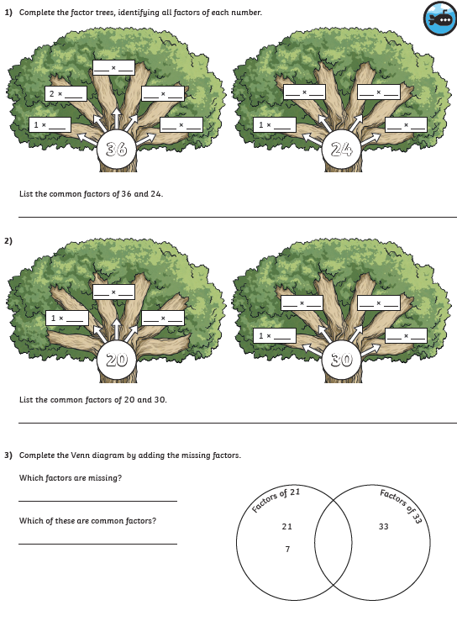

WALT: understand factors SO THAT we can find common factors of numbers



GOING FOR GOLD

WALT: understand factors SO THAT we can find common factors within our timestables

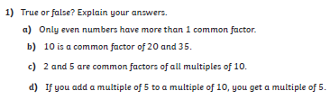



WALT: understand factors SO THAT we can find common factors within our timestables

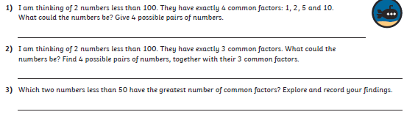

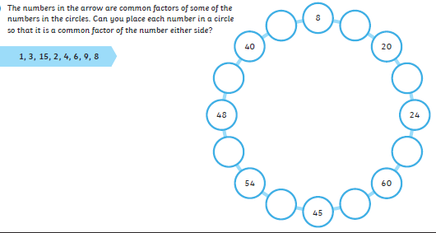

GOING FOR GOLD

Bronze:

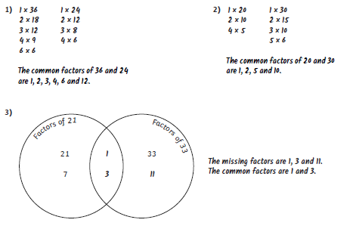

Silver:

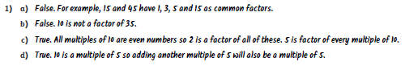

Gold:

