

GOING FOR GOLD

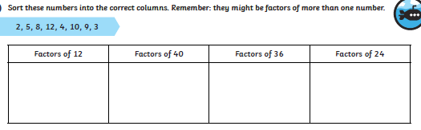

WALT: understand factors SO THAT we can find factors within our timestables



GOING FOR GOLD

WALT: understand factors SO THAT we can find factors within our timestables

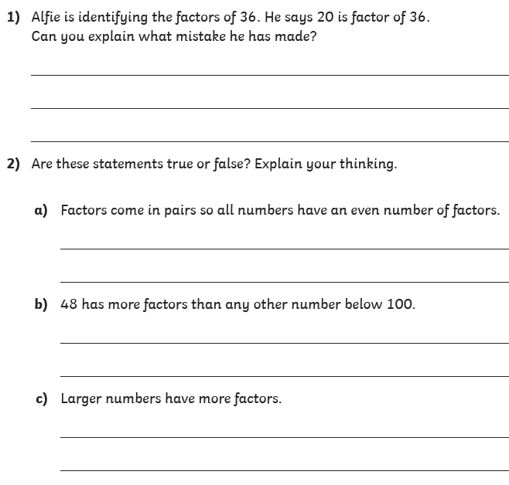

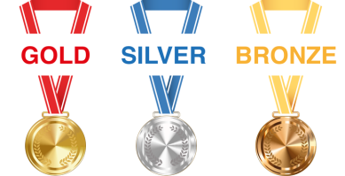

WALT: understand factors SO THAT we can find factors within our timestables

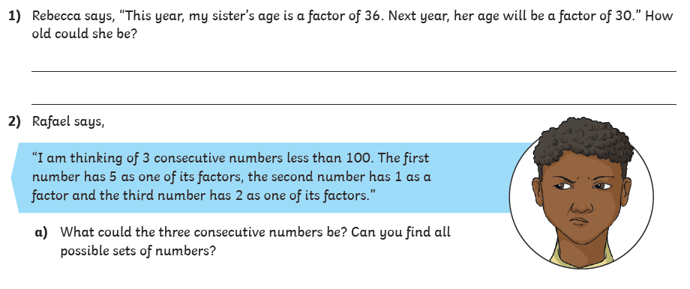

There are 9 possible answers for question 2.

GOING FOR GOLD

Bronze:

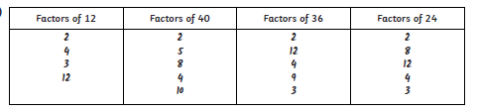

Silver:

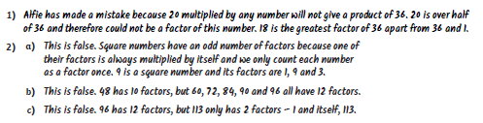

Gold:

