

GOING FOR GOLD

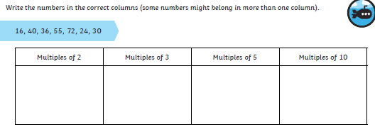

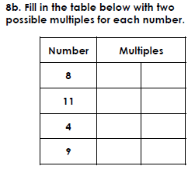

WALT: understand multiples SO THAT we can find multiples within our timestables



GOING FOR GOLD

WALT: understand multiples SO THAT we can find multiples within our timestables

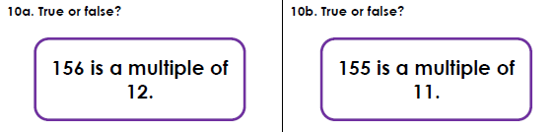 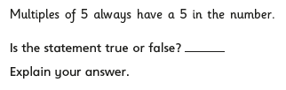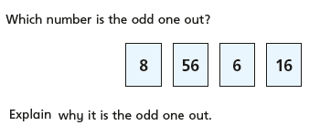



WALT: understand multiples SO THAT we can find multiples within our timestables

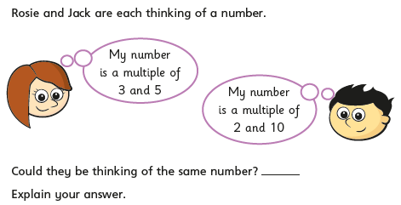 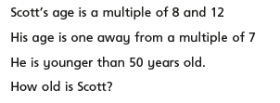 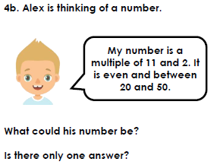 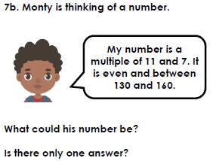

GOING FOR GOLD

Bronze:

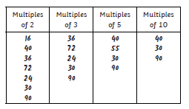

Any numbers in the x timestable per question.

Silver:



2) 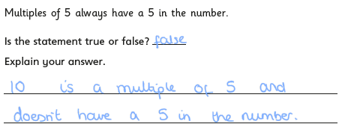

3) Diff answers : e.g. 6 because 8,56 and 1 are not multiples of 6 they’re all multiples of 8

Gold:

