

We are learning to add crossing 10 **so that** we can add 2-digit and 1-digit numbers.

GOING FOR GOLD

**1**

**2**

**4**

**3**

**6**

**5**



We are learning to add crossing 10 **so that** we can add 2-digit and 1-digit numbers.

We are learning to add and subtract **so that** we can add or subtract ones.

.

GOING FOR GOLD

**1.**

**2.**

v

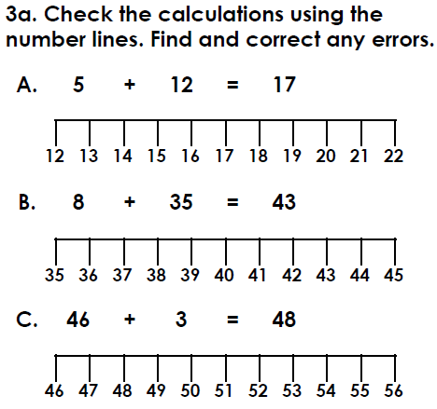

**3.**

**4.**

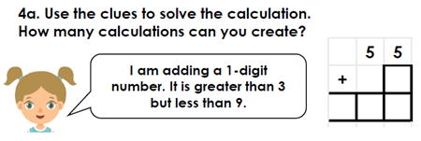

**5.**





We are learning to add crossing 10 **so that** we can add 2-digit and 1-digit numbers.

GOING FOR GOLD

**1..**

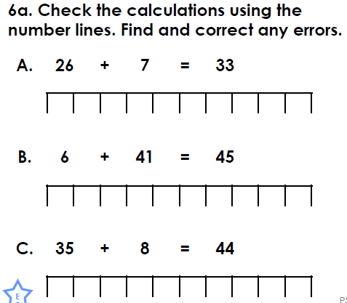 **2.**

14

+ 3

14

+ 3

**3.**

**4.**

**5.**

We are learning to add crossing 10 **so that** we can add 2-digit and 1-digit numbers.

GOING FOR GOLD

**1..**

