We are learning to use the column method so that we can subtract 2-digit and 1-digit numbers.
GOING FOR GOLD

1. | 2 | 5 |  | 2. | 3 | 4 |  | 3. |  | 4 | 4 |  | 4. | 5 | 6
- |  | 9 |  | - |  | 8 |  | - |  |  | 5 |  | - |  | 7
5. | 6 | 3 |  | 6. | 7 | 4 |  | 7. |  | 8 | 5 |  | 8. | 9 | 6
- |  | 9 |  | - |  | 7 |  | - |  |  | 8 |  | - |  | 9
9. Pick a 2-digit card and a 1-digit card and add them together. Can you create 3 calculations. Use the column method to find your answer.  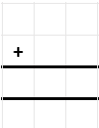  53  51  52 |  |  |  |  |  |  |  |  | 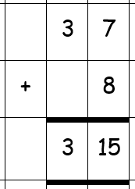  10. Is the calculation correct. Explain your answer?  9  3

We are learning to use the column method so that we can add 2-digit and 1-digit numbers.
.
GOING FOR GOLD

Use the column method to work out the answer
1 | 2.
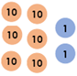  3. | 4.  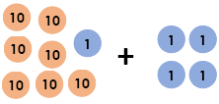
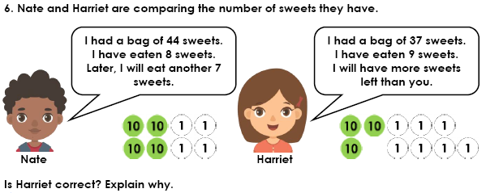
5.

GOING FOR GOLD
We are learning to use the column method so that we can add 2-digit and 1-digit numbers.

1. Work out the calculation below.  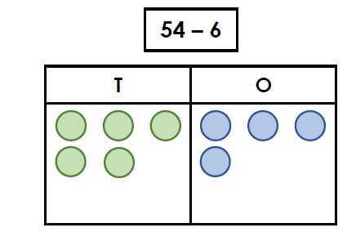 | 2. Use the column method to find the correct answer to the calculation below.
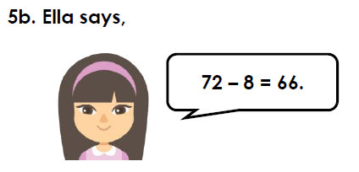  3.  Is she correct? Use the column method to prove it. | 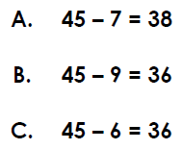  4.  Use the column method to help you find the odd one out.
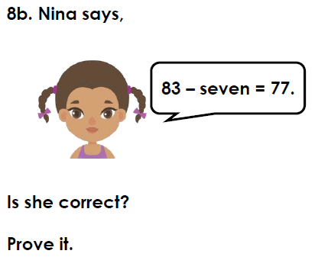  5. | 6. Pick a 2-digit card and a 1-digit card and subtract them. Can you create 3 calculations. Use the column method to find your answer.  