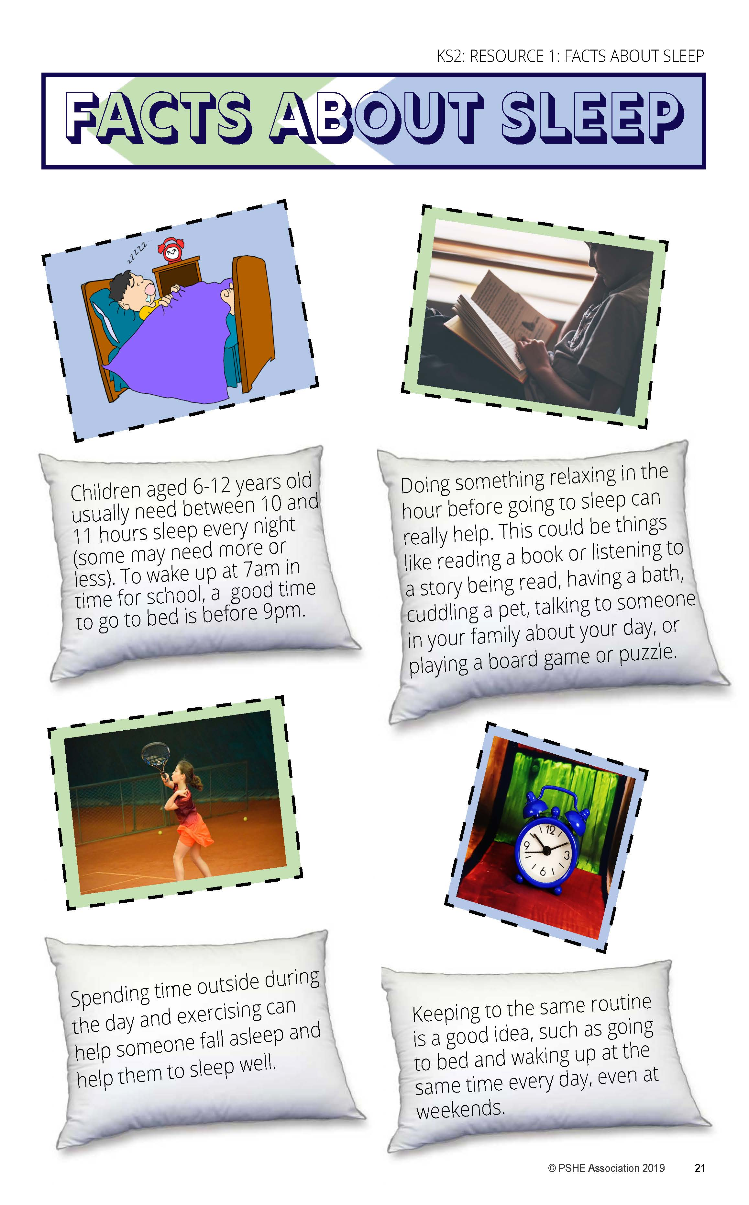
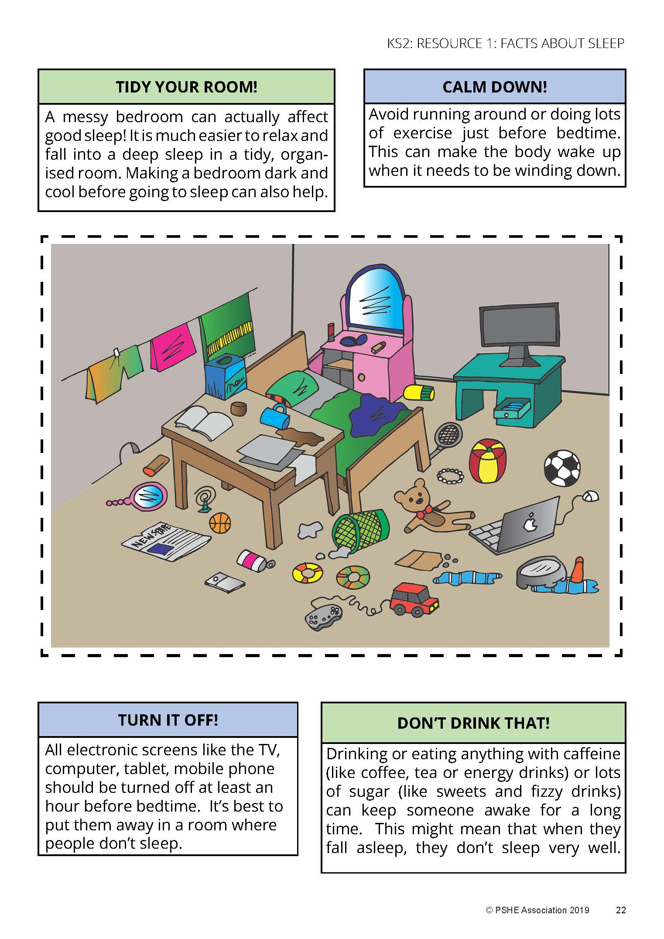
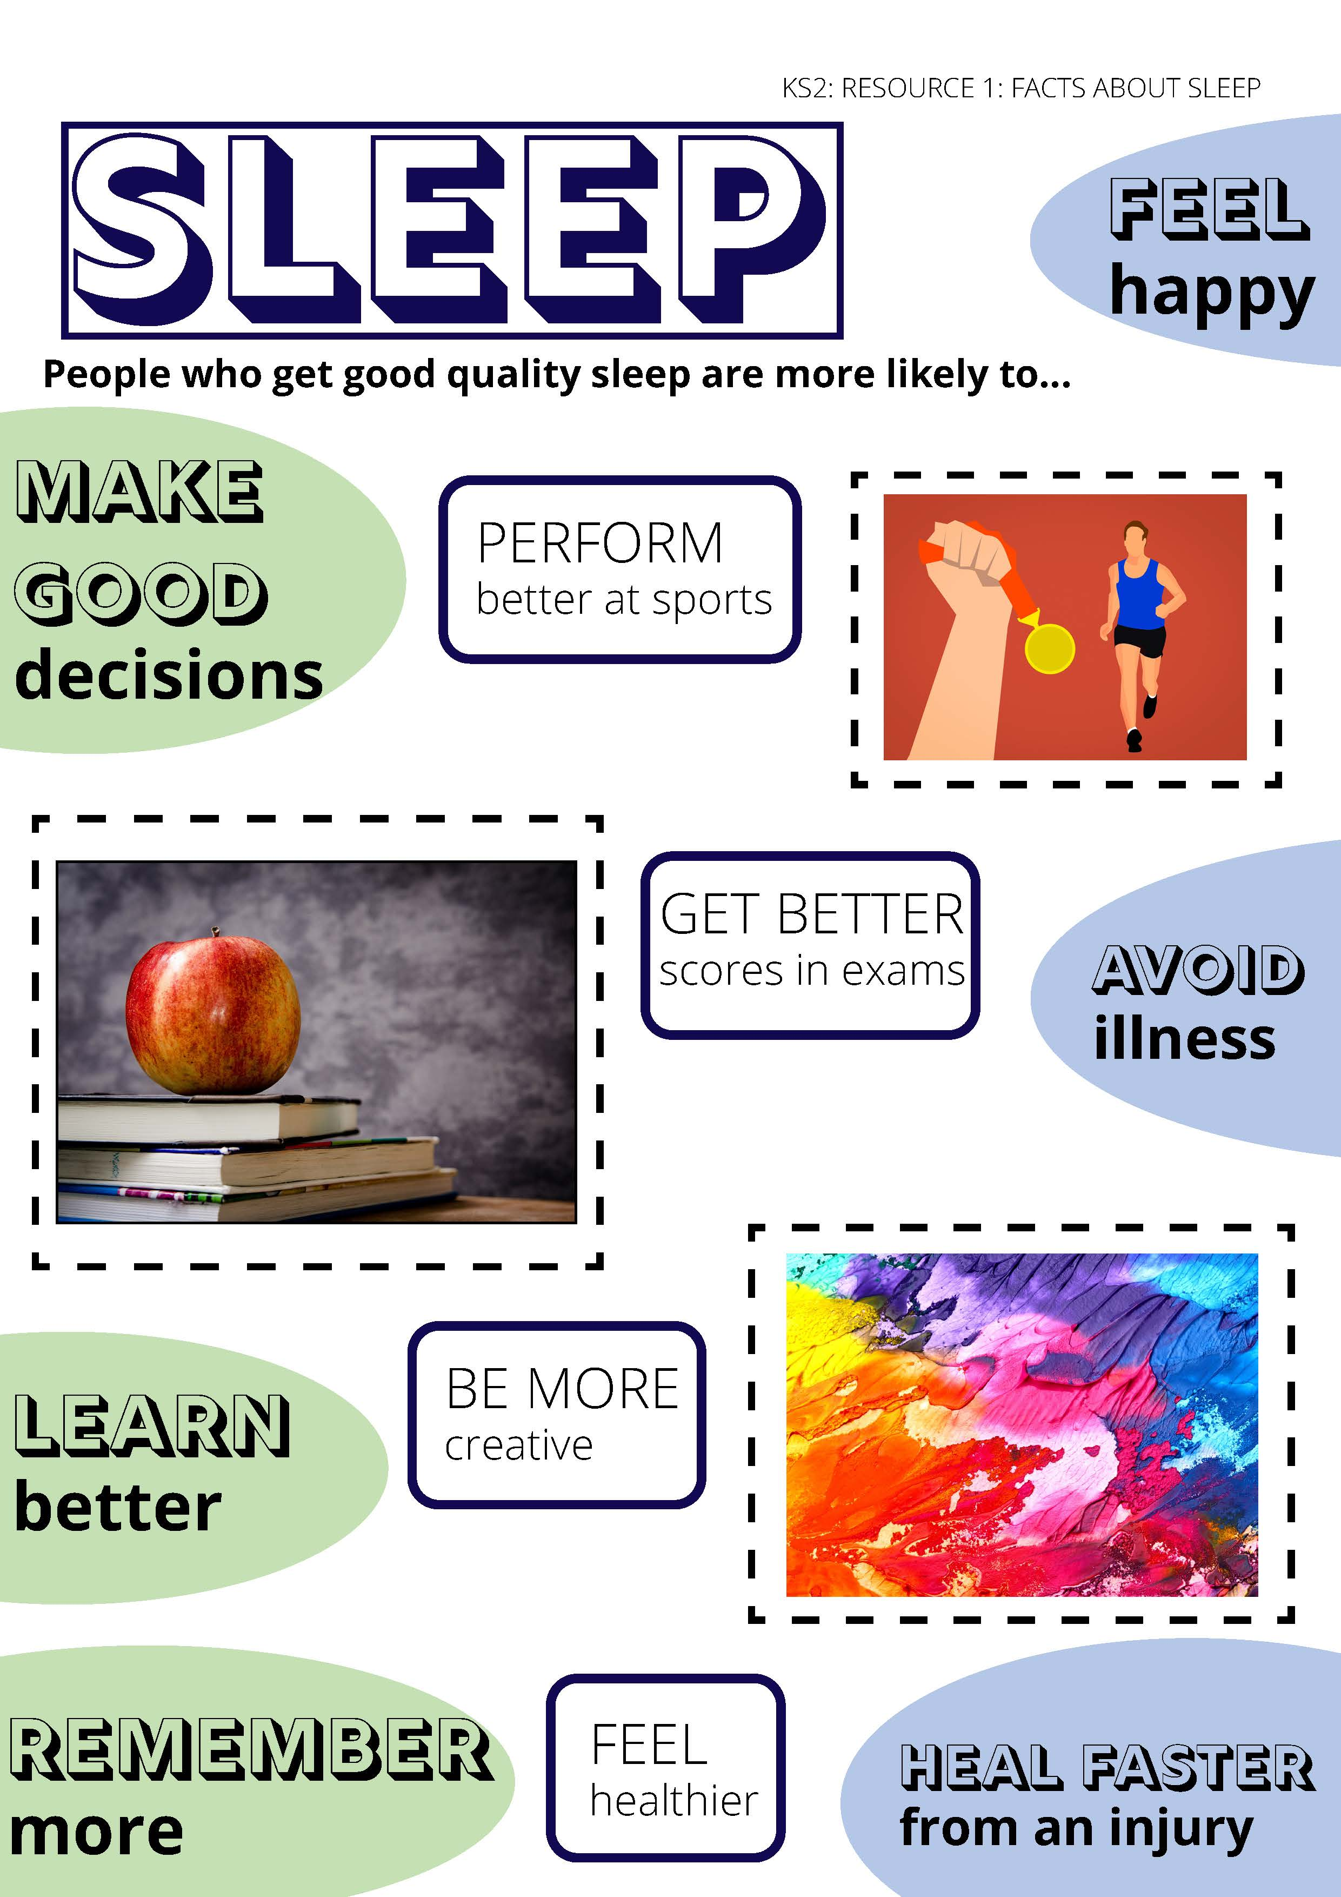

ACTIVITY 1: MY SLEEP FACTFILE

QUESTION | ANSWER
How much sleep do children need each night?
Find 3 things to start doing that help someone get good sleep:
Find 3 things to stop doing that would help someone sleep:
Why is it important to get good sleep?
*CHALLENGE question: Why is it more important to get sleep during puberty?

ACTIVITY 2: SLEEP BUSTER SOLUTIONS

It is difficult to go to sleep when… | A solution to this might be….
Someone has been watching TV, or playing games online before bed
Someone is nervous or worried about something, e.g. a test at school
Someone drinks a sugary drink, such as orange juice or hot chocolate, before bed
Individual steps I would need to take to carry out the sleep solution ……

