

Sleep tips

Avoid

Try

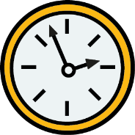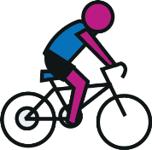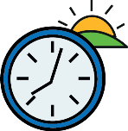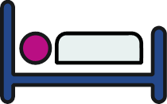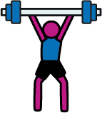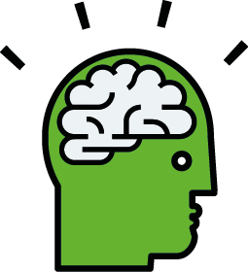

Using screens of any kind an hour before bedtime and don’t look at them through the night

Doing something relaxing before bed like sketching or reading

JOB NO 1778 SEP20

Getting outside first thing on a morning to set your body clock

Warm milk, water or herbal tea for supper

A healthy supper no later than 30 minutes before bed

Keep your bedroom tidy, organised and device free

Using an alarm clock instead of the alarm on your phone

Exercising in the daytime, especially in the morning

Sugary food and drinks or heavy meals close to bed time

Caffeinated drinks or energy drinks particularly after lunch time

Going to sleep at inconsistent times and having naps

Exercise in the hour before you go to bed

\*yoga and meditation are the exceptions

Over-stimulating bedroom environments