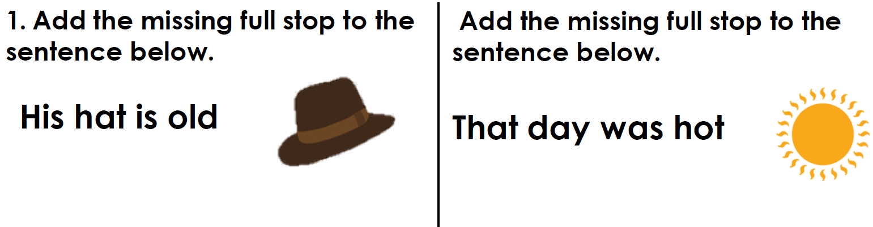

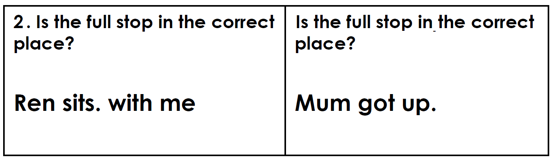

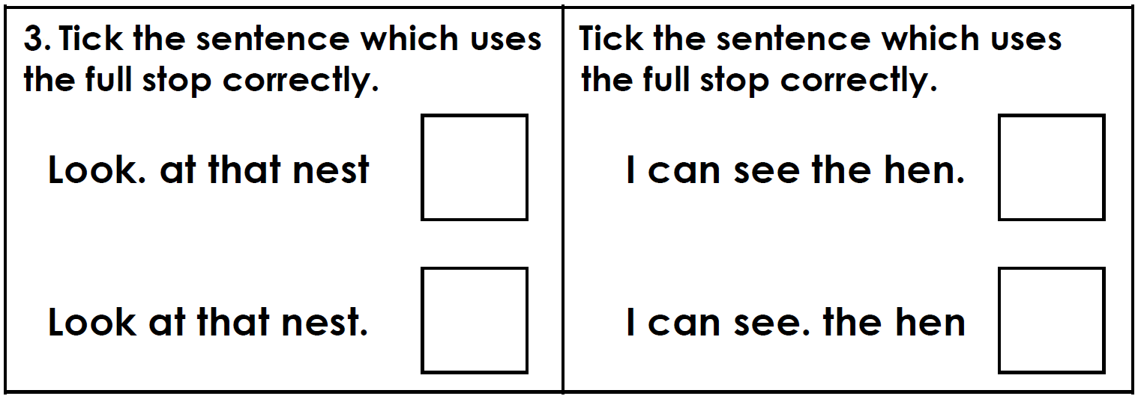

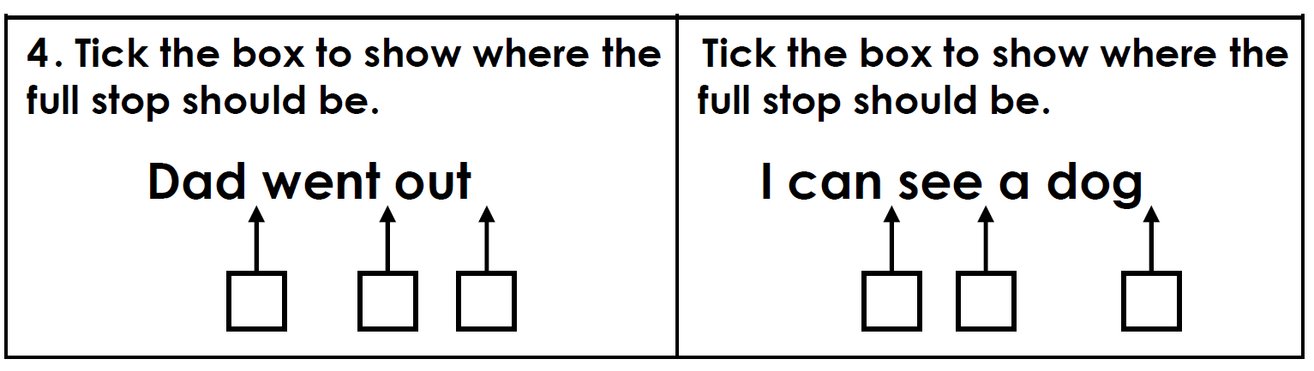

Read these sentences. Write each one again with a full stop in the right places.

- The fox went in his den
____________________________________________________________________________________________________________

- Mum is going to the shop
____________________________________________________________________________________________________________

- Tim the cat sits on the mat
____________________________________________________________________________________________________________

- Dad looks in the box
____________________________________________________________________________________________________________

- I can see the beach
____________________________________________________________________________________________________________

- Nan has a cat and dog
____________________________________________________________________________________________________________

