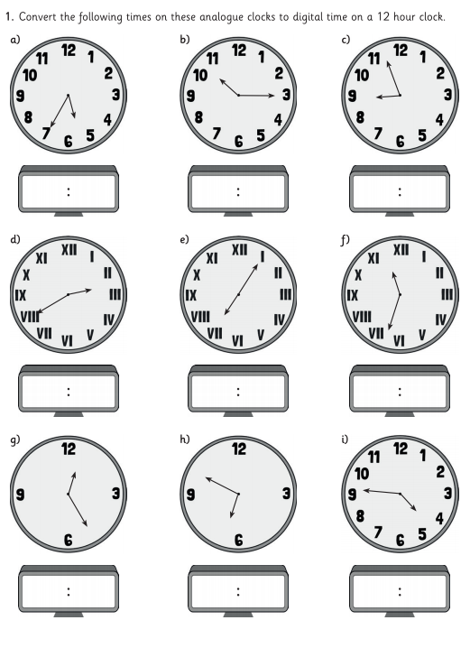

Maths- Lesson 2

5 35