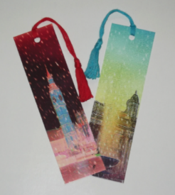  Design and make your own book mark. | Design a new front cover for your favourite book  and/or  Design a front cover for your haunted house story. Remember to include a story title and the author on the front page  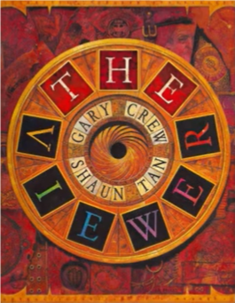 | Write a book review on your favourite story.  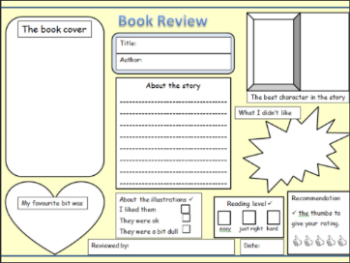  Why is it your favourite? How many times have you read it? Who are the characters? What happens? |  | Research a favourite author and write some facts/draw some pictures…  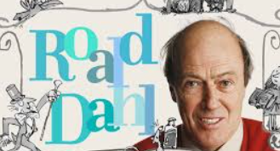  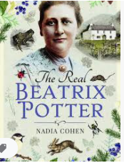  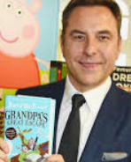
Get creative and draw or make your favourite book character.  You could even use a spoon or a potato!  https://www.worldbookday.com/fun-craft-favourite-characters/  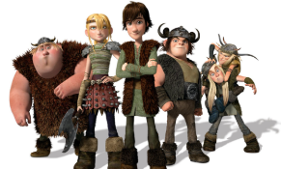 | World Book Day  Thursday 4th March 2021  Here are a variety of activities for you do to celebrate World Book Day.  Please complete at least 3 activities.  These should be finished by 2.15pm so that we can meet for the last lesson at 2.30pm where we can share our work.  Everything that you will need is on this sheet. |  | Take a ‘shelfie’ of your favourite books from home that you have enjoyed.  Share a picture of your favourite books explain why you like them!  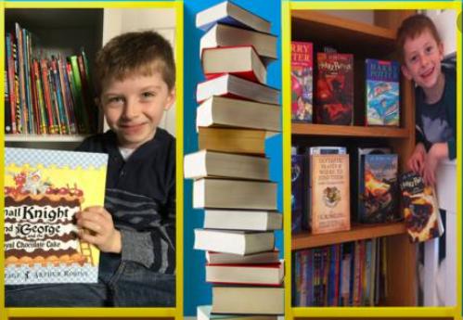
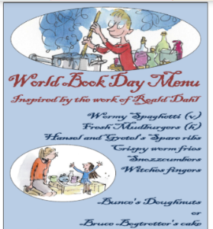  Create a meal plan for a book character or author. You could do some cooking based around your favourite story. | Design a book token competition for World Book Day.  Look at the examples of previous winners here:  https://www.worldbookday.com/competitions/design-a-national-book-token-2021/  Use this template:  http://www.hendalprimary.org.uk/wp-content/uploads/2021/02/Book-token-template.pdf | The Viewer  Write a narrative to tell the story of what happened next to the boy and his home.  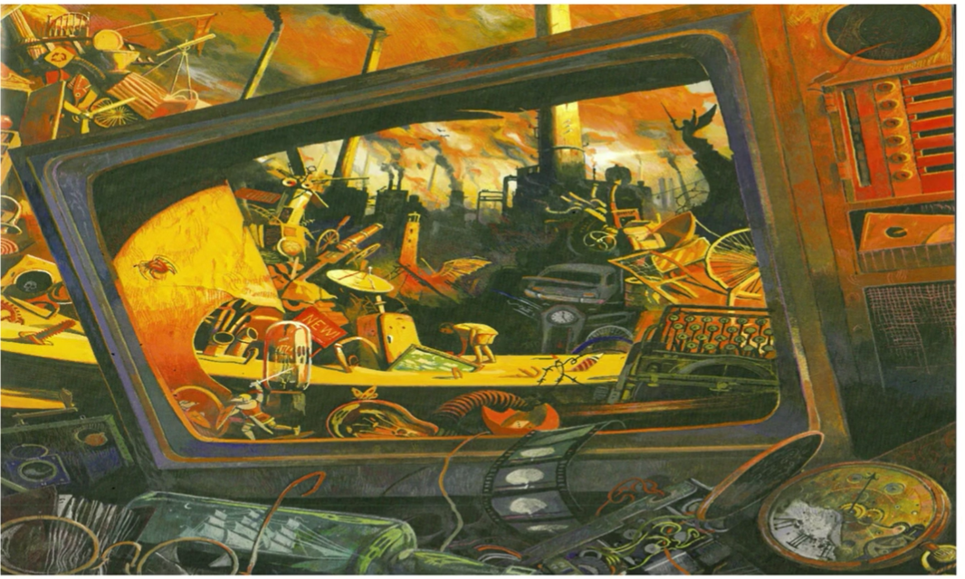 | Listen to an audiobook.  This link has a variety of audiobooks to listen to for free. https://www.worldbookday.com/world-of-stories/  