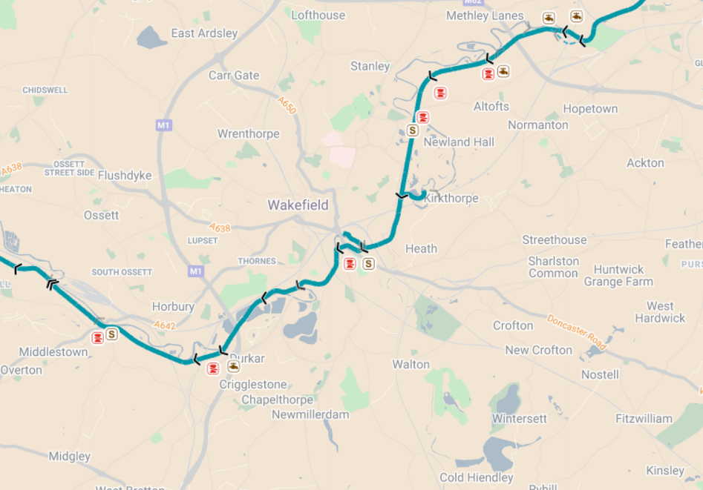

- Can you find where you live on the map above?
- Do you live near a canal? What is it called?
- Where does it go?
- What is its length?
- How many locks does it have?

Extension: Does it feed into any other canals?

Wakefield Branch (Aire & Calder Nav) | Canal maps | Canal & River Trust

