**Recognise and Name 3D Shapes – Extension Task**

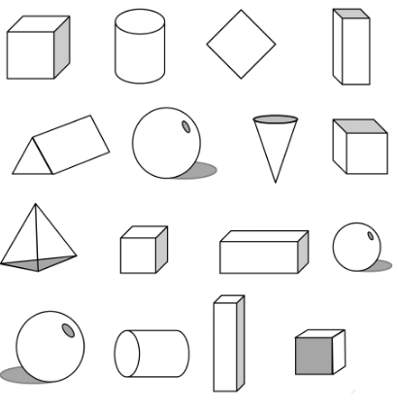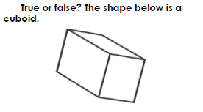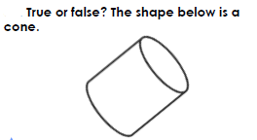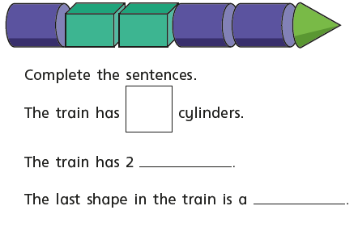

______ Cubes

______ Cylinders

______ Cone

______ Cuboids

______ Spheres

______ Triangular prism

______ Pyramid

4. Look at the 3D shapes below. How many of each shape are there?

3.

2.

1.