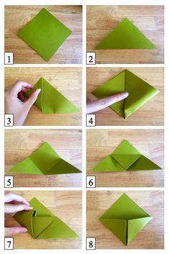

Follow the step by step instructions below to make your own origami corner book mark. Remember to then decorate your bookmark.

Use the ideas on the bookmark idea sheet to help you.