WALT use inference, giving evidence from the text
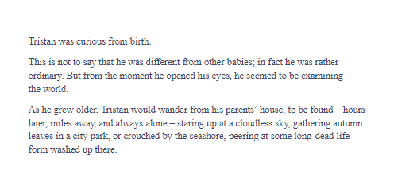
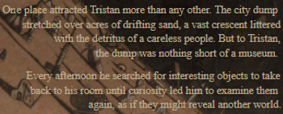
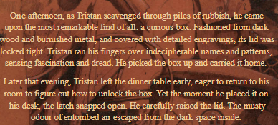
- What do we learn about Tristan from these extracts? Give two ideas using evidence from the text.

- What evidence is there that Tristan doesn’t view rubbish the same way as other people?

- What is strange or different about the box he finds? List two different ideas with evidence from the text.

- What do you think the box is for? Predict what might happen next in the story.

