Count Faces on 3D Shapes

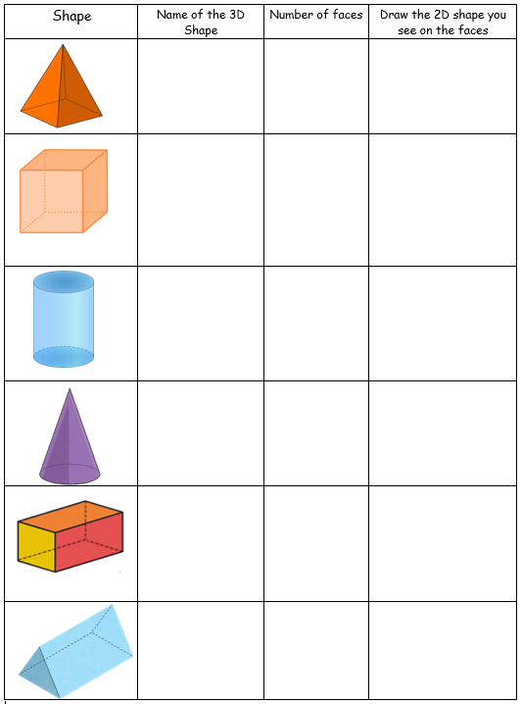
Complete the table below.

