



GOING FOR GOLD

We are learning to make patterns with 2D shapes SO THAT we can recognise patterns.

.

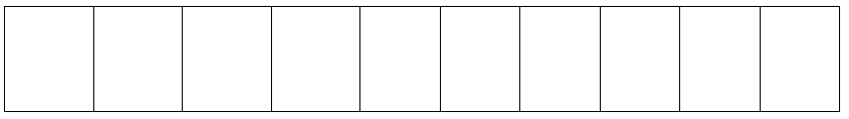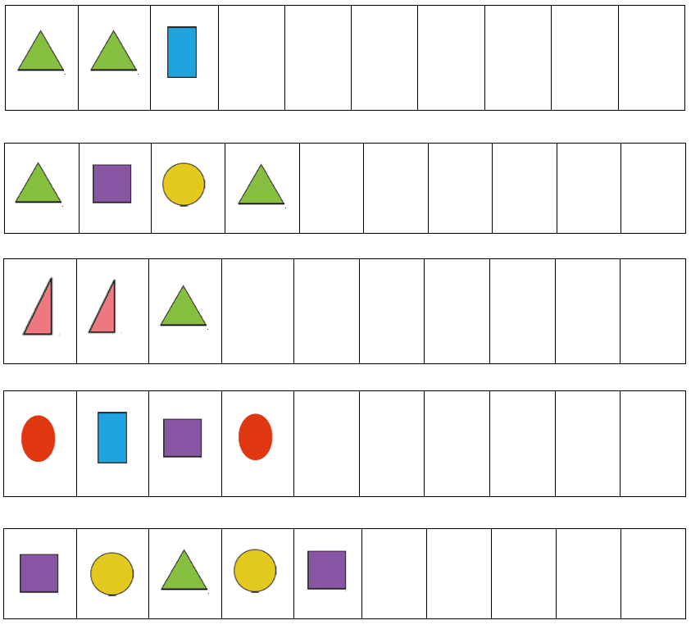

Create your own 2D shape pattern using any of the shapes above.

Complete the 2D shape patterns below.