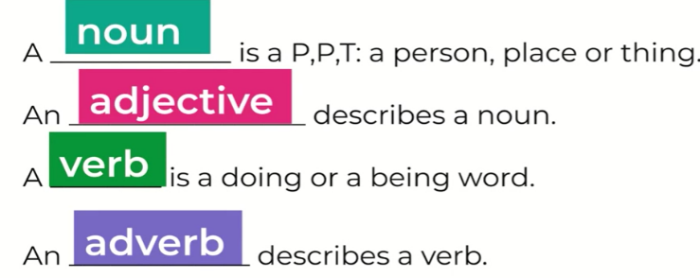
Gold
Verbs | searched hunted scavenged examined collected shuffled leaned sat lay perched balanced slept rested ticked waited billowed towered
Adverbs | carefully desperately inquisitively curiously silently gradually cautiously monstrously menacingly patiently
Use the adjectives, nouns, verbs and adverbs from the last two lessons to write 4 sentences to describe the setting.
One sentence needs to include a relative clause.
Use one example of personification.
1.

2.

3.

4.

