Noun | Adjective | Adjective
Bronze
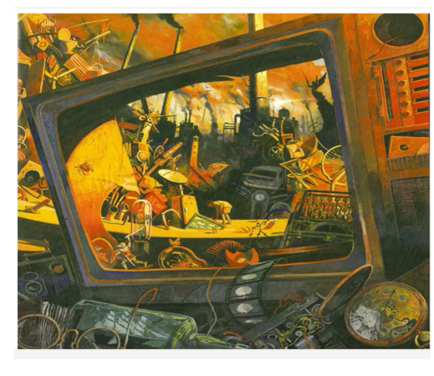
Word bank
Television film reel glasses pocket watch chimneys satellite bicycle wheel
Amber ominous cloud-scattered murky
Filthy towering smashed rusty broken circular skinny dark-haired

