

GOING FOR GOLD

We are learning to multiply the answer by the denominator SO THAT we can find the starting amounts.

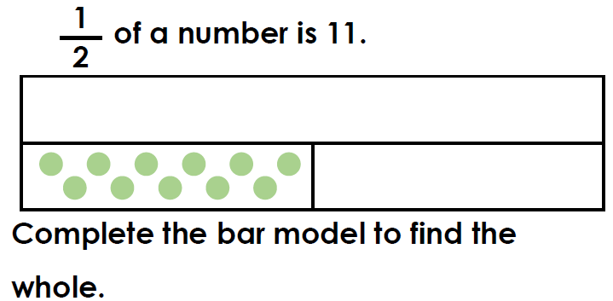

1.

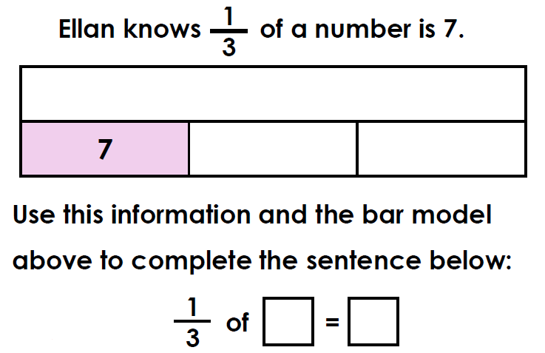

2.

3.

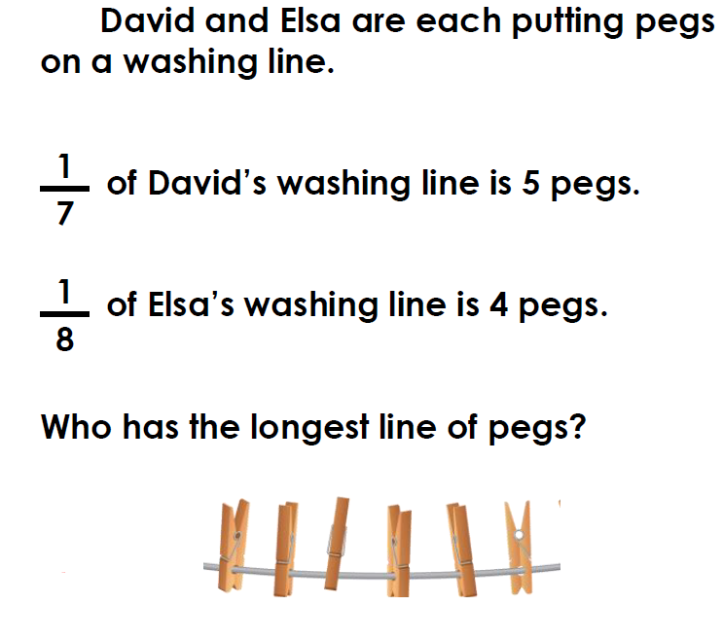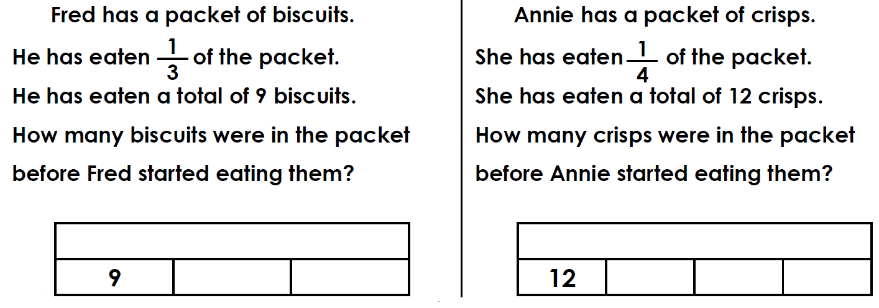

5.

4.





GOING FOR GOLD

We are learning to multiply the answer by the denominator SO THAT we can find the starting amounts.

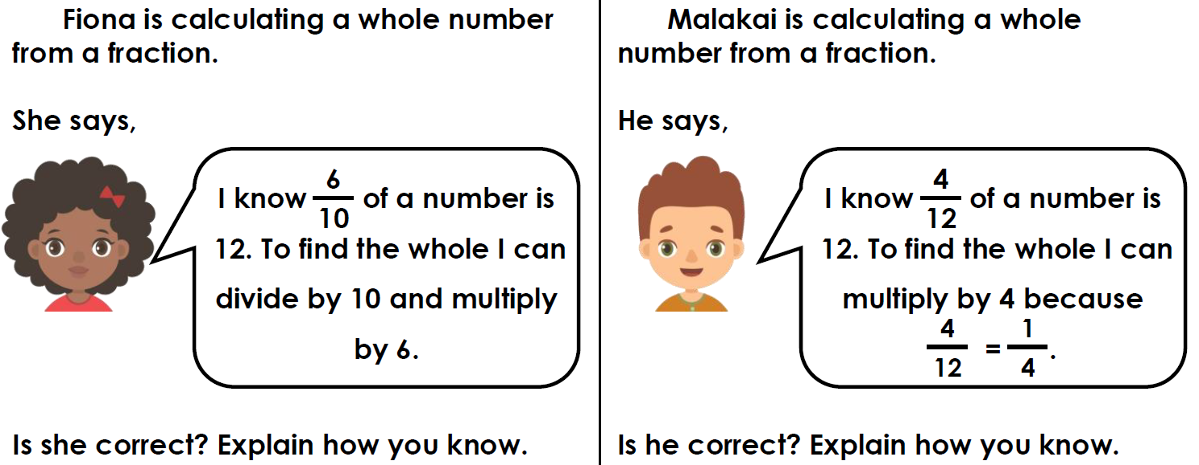

1.

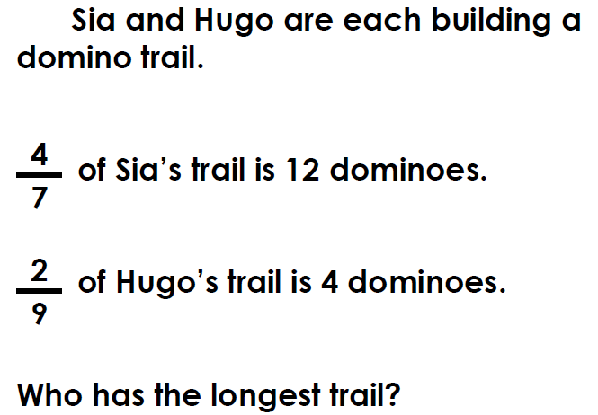

3.

2.

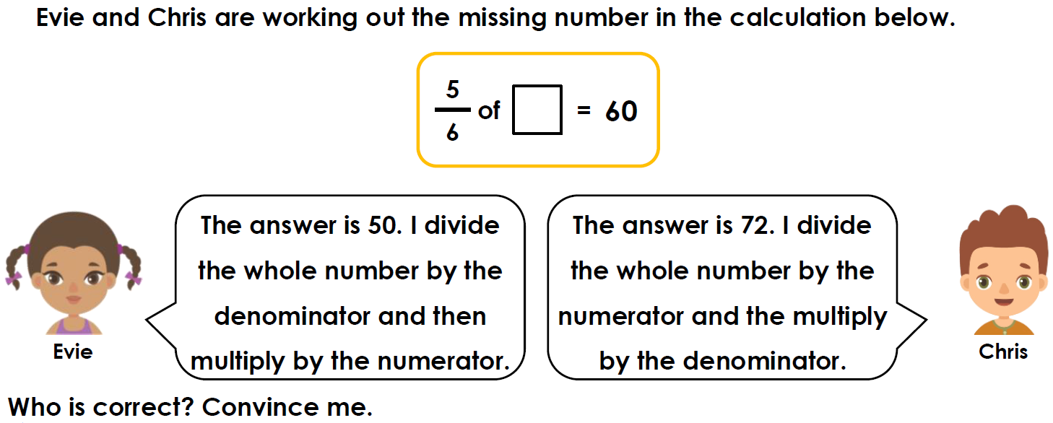

4.



GOING FOR GOLD

We are learning to multiply the answer by the denominator SO THAT we can find the starting amounts.

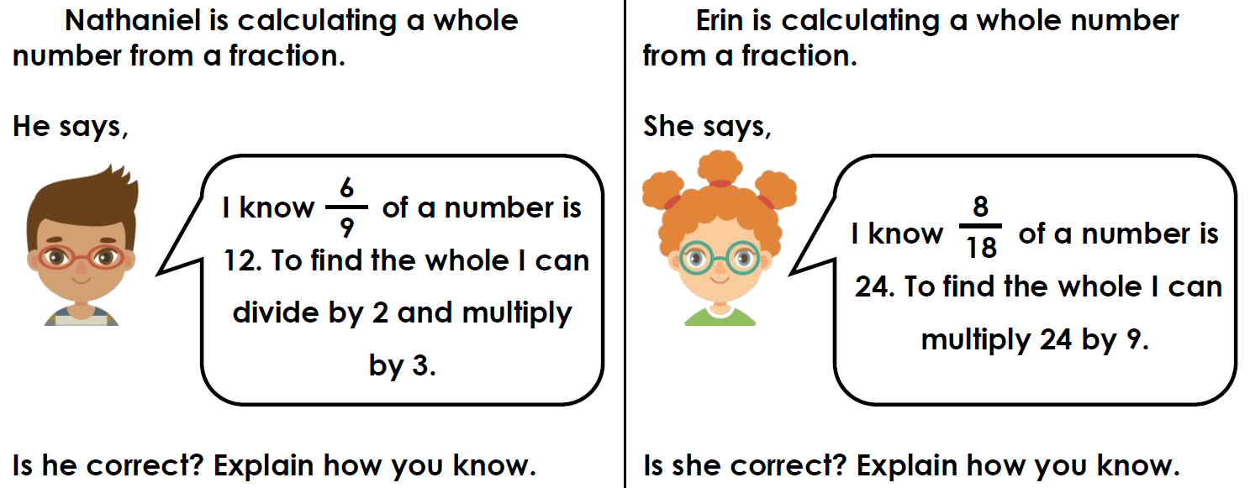

CLUE  
Box number 1 is a multiple of 5.

1.

2.

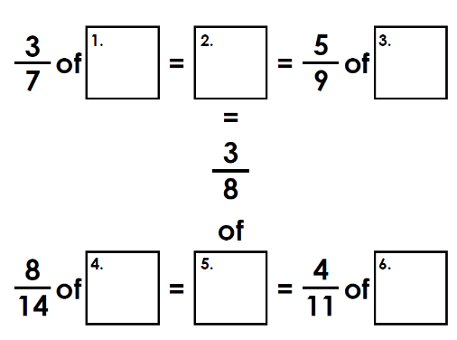

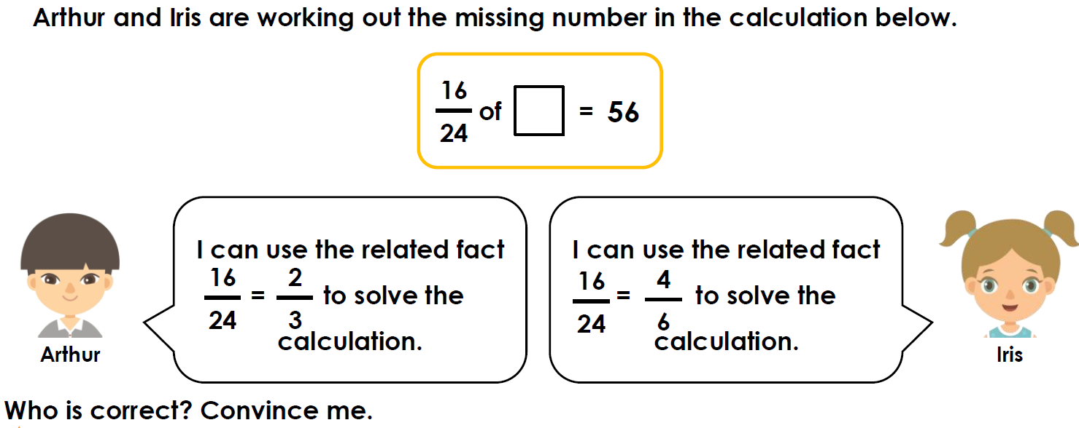

3.