

GOING FOR GOLD

We are learning to multiply the answer by the denominator SO THAT we can find the starting amounts.

1.

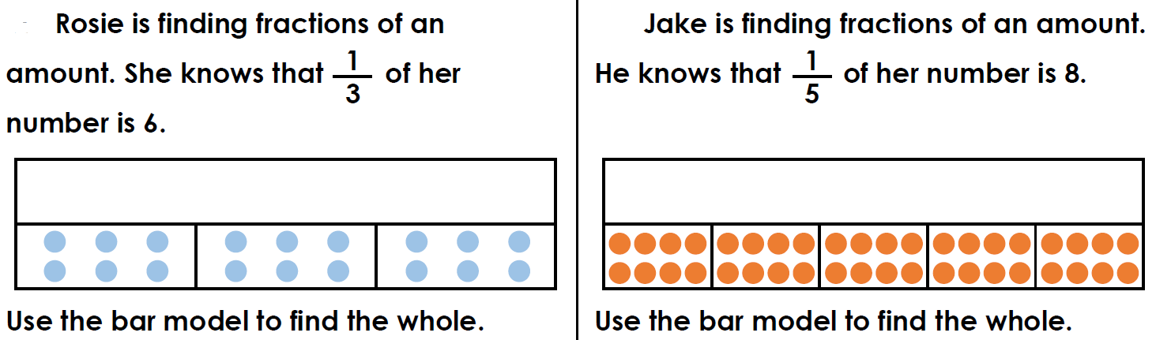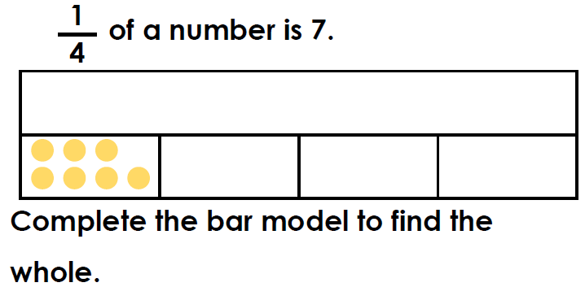

2.

3.

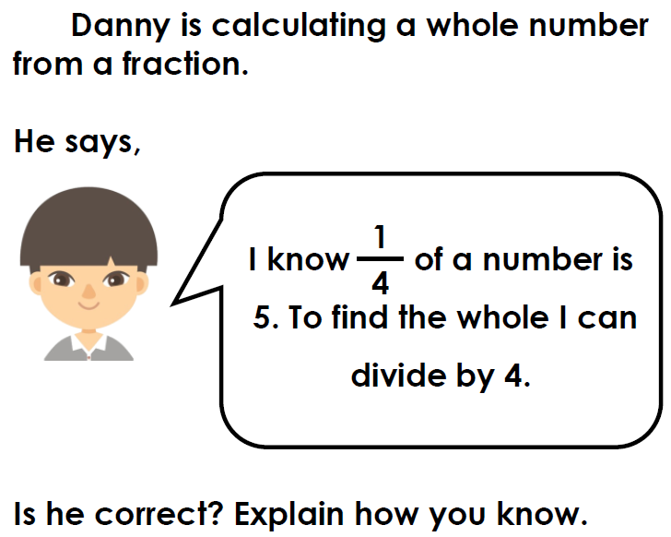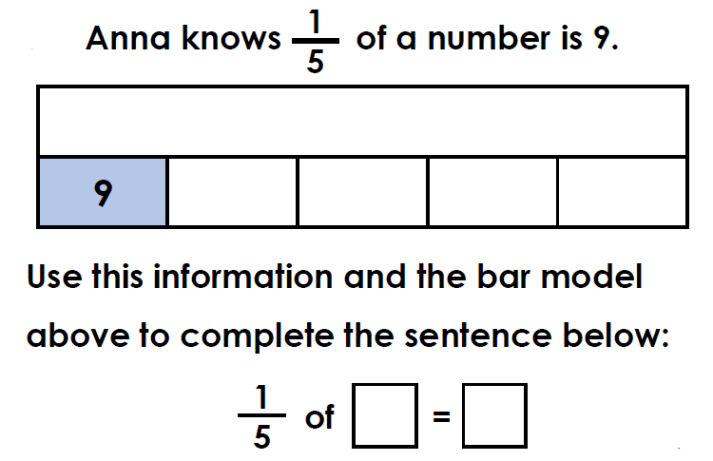

5.

4.





GOING FOR GOLD

We are learning to multiply the answer by the denominator SO THAT we can find the starting amounts.

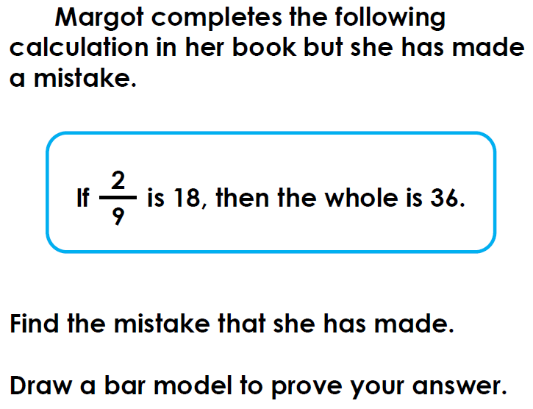

1.

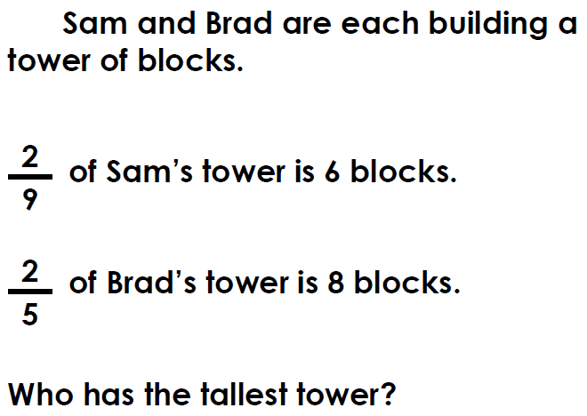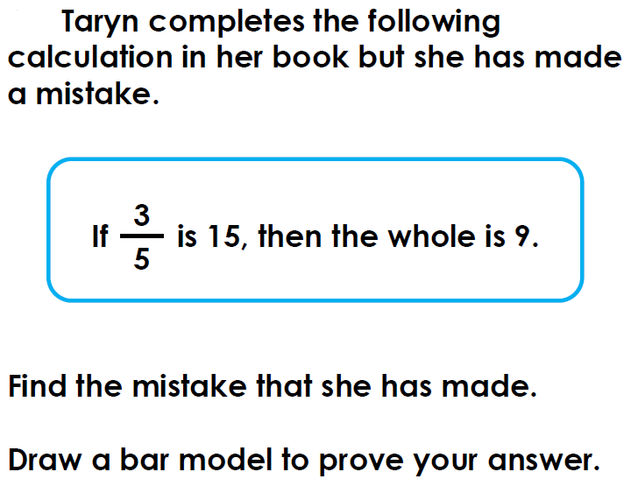

3.

2.

4. Millie says the starting amount for this fraction is 30.

Is she correct? Prove it.

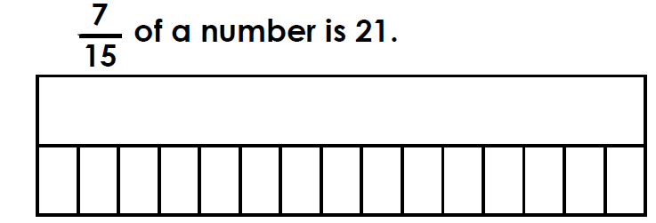

5.

John says: The whole is 63.

Is he correct? Prove it.

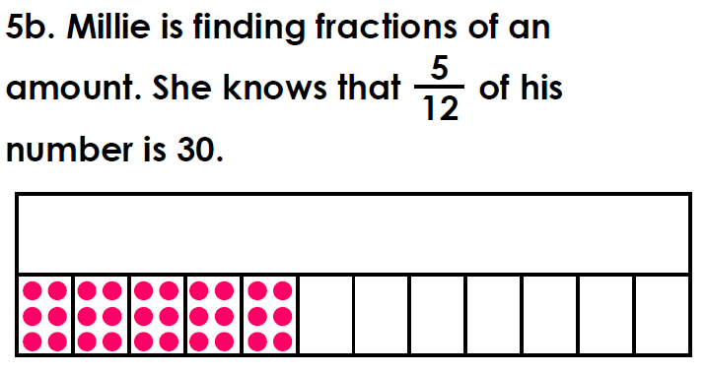



GOING FOR GOLD

We are learning to multiply the answer by the denominator SO THAT we can find the starting amounts.

1.

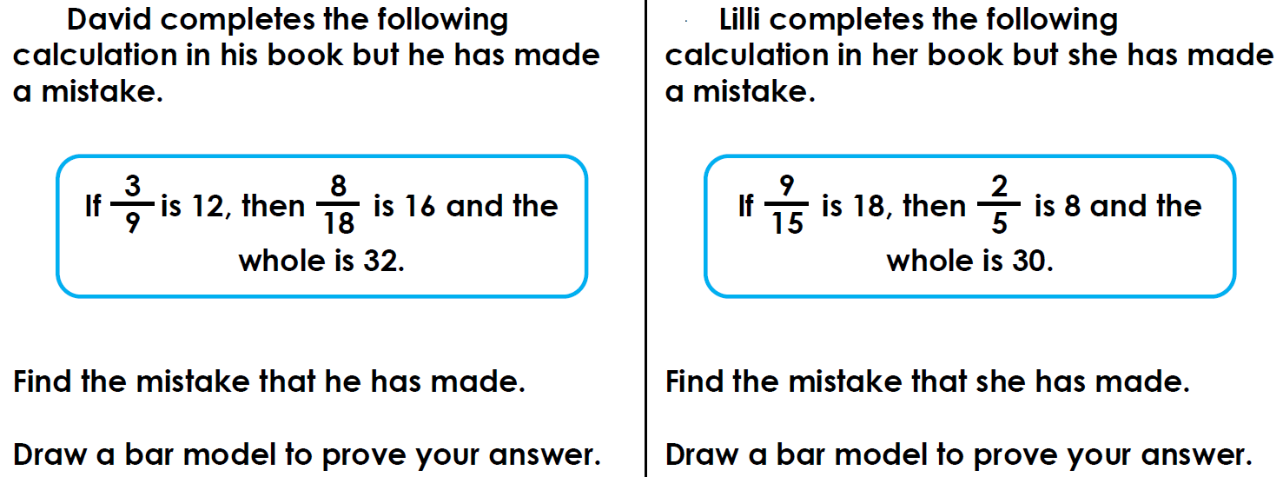

2.

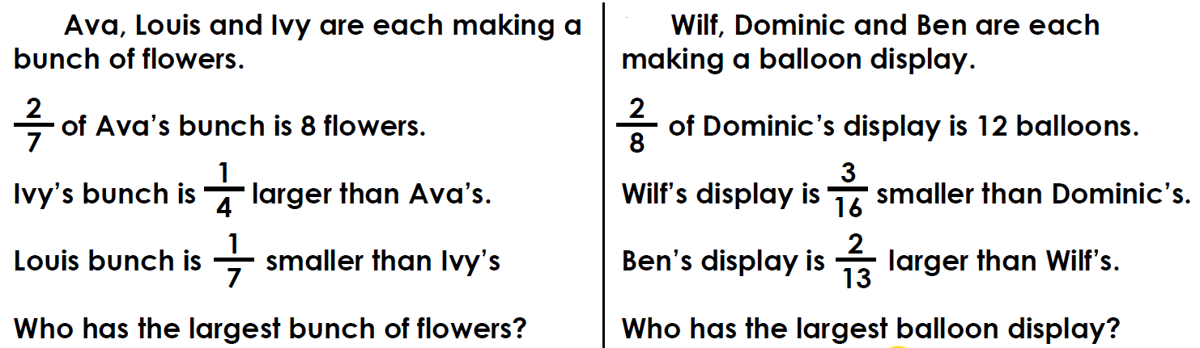

4.

3.