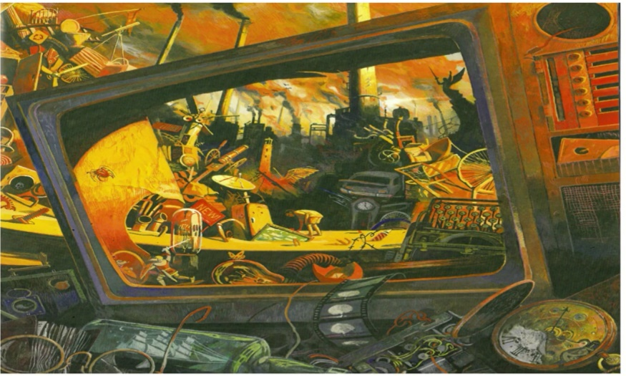

Gold
What is your impression of the setting? What evidence is there? Give two reasons.

Which objects does the ‘writer’ want us to pay attention to? How do you know?
Why might they be important?
Do you know any stories or films which could have a similar theme?

