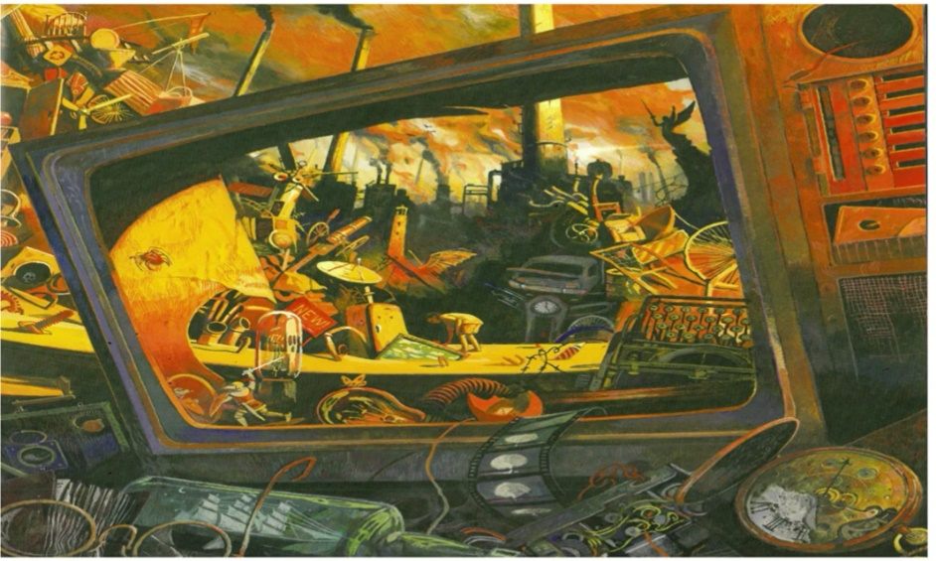
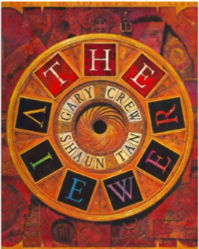

Bronze
What images are on the front cover?

List 6 images from the first page which you think are most important?
What do you think the boy is doing?
Write 3 questions which you would like to ask the author.

