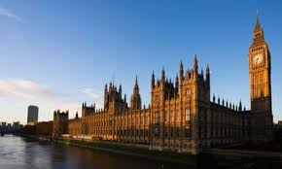

Parliament Week

Sunday 1st November - Saturday 7th November

During the week commencing Monday 2nd November, every class in school will be holding an election to select one child for each of the roles below.

* Class Councillor
* Class Break Time Buddy
* Eco-Councillor
* Art Ambassador
* ICT Ambassador

As homework, we would like to ask your child to prepare a written speech for at least one of the roles they would like to be elected for. It will then be left to the rest of the class to vote for their winner.

Best of luck!

