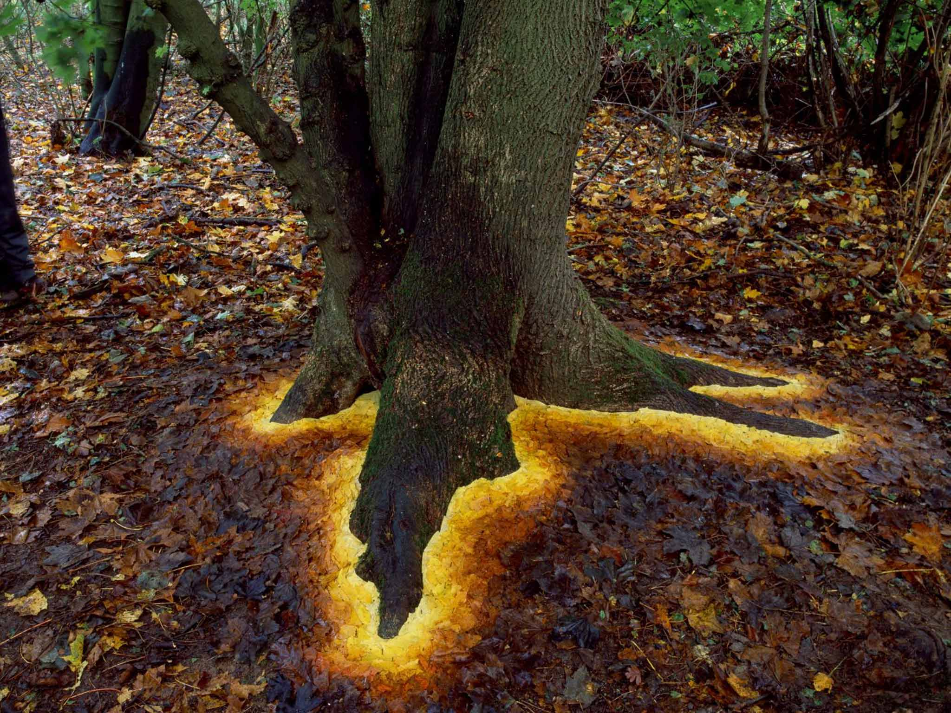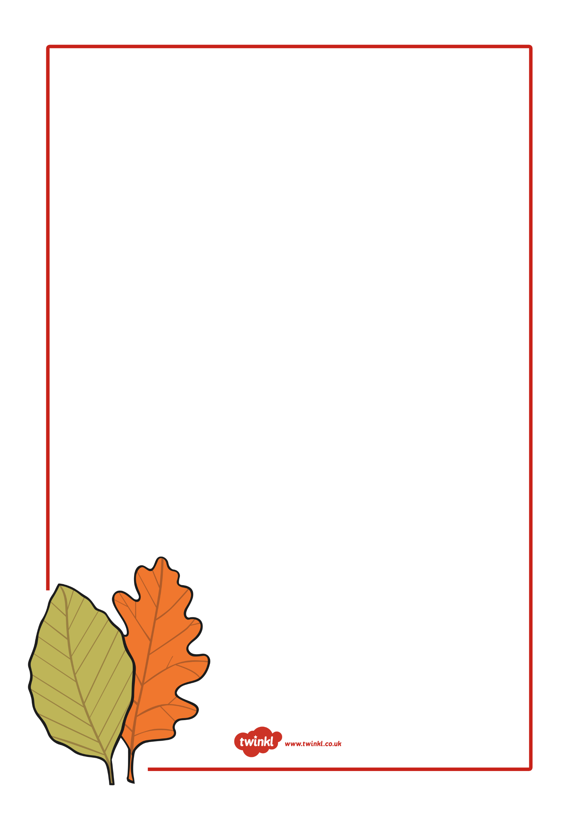

Friday 23rd October

In Autumn

Natural art by Andy Goldsworthy

___________________________________________________________________________________________________________________________________________________________________________________________________________________________________________________________________________________________________________________________________________________________________________________________________________________________________________________________________________________________________________________________________________________________________________________________________________________________________________________________________________________________________________________________________________________________________________________________________________________________________________________________________________________________________________________________________________________________________________________________________________________________________________________________________________________